[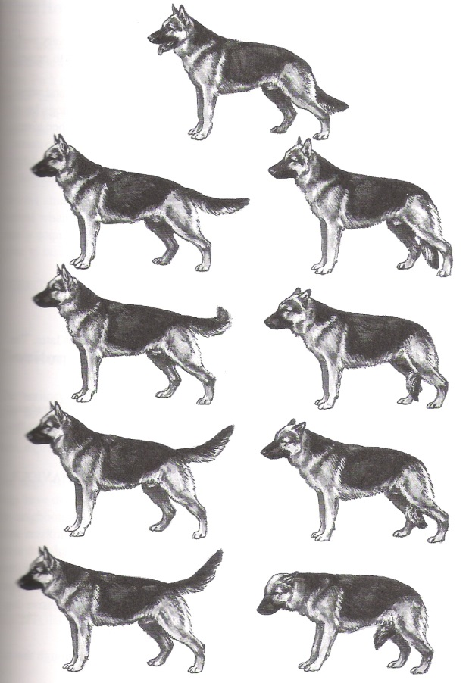](http://www.google.nl/url?sa=i&rct=j&q=&esrc=s&source=images&cd=&cad=rja&uact=8&ved=0ahUKEwjxjqDtwpXWAhWBWxoKHQIPB5gQjRwIBw&url=http%3A%2F%2Fwww.toscanzahoeve.be%2Fde-staart-bij-honden-moet-verlagen-uit-respect%2F&psig=AFQjCNFmQ1-ZB4N2vSMUrQhqTDRn2e0oyg&ust=1504957793531117)

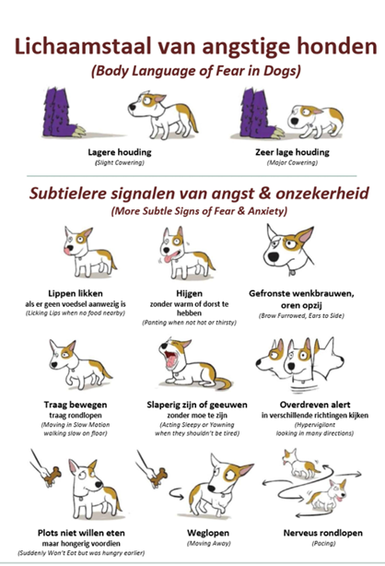

[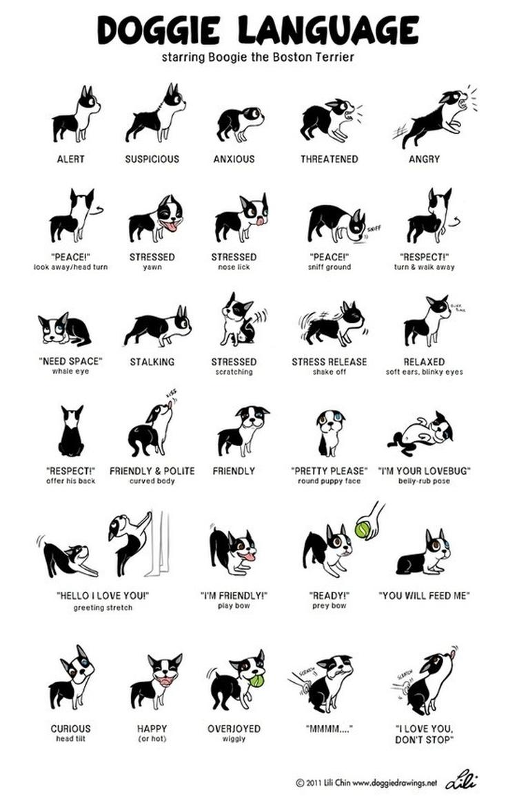](http://www.google.nl/url?sa=i&rct=j&q=&esrc=s&source=images&cd=&cad=rja&uact=8&ved=0ahUKEwjh17Wnw5XWAhWDuhoKHWhnDccQjRwIBw&url=http%3A%2F%2Fwww.welke.nl%2Fphoto%2Ftoerzeilster%2Fhonden-gedrag.1419706237&psig=AFQjCNFmQ1-ZB4N2vSMUrQhqTDRn2e0oyg&ust=1504957793531117)

[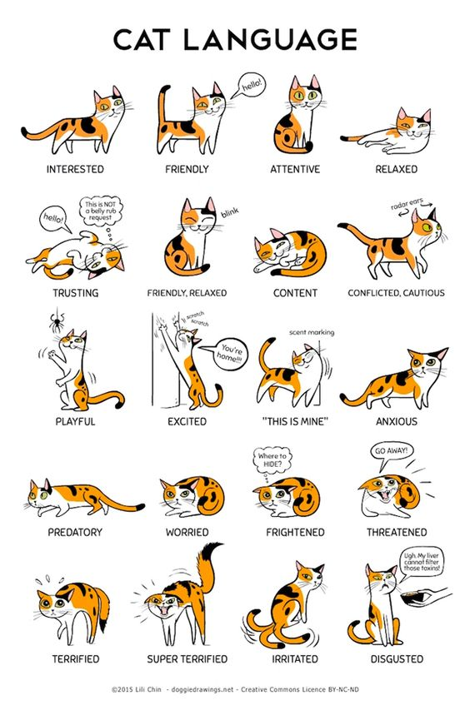](http://www.google.nl/url?sa=i&rct=j&q=&esrc=s&source=images&cd=&cad=rja&uact=8&ved=0ahUKEwixofS5w5XWAhUJPxoKHbX-CkcQjRwIBw&url=http%3A%2F%2Fcatterrific.nl%2Flichaamstaal-kat-uitgelegd%2F&psig=AFQjCNFsAcVatP5OTUbw3rw1VqWPd2gNxg&ust=1504957965164376)

[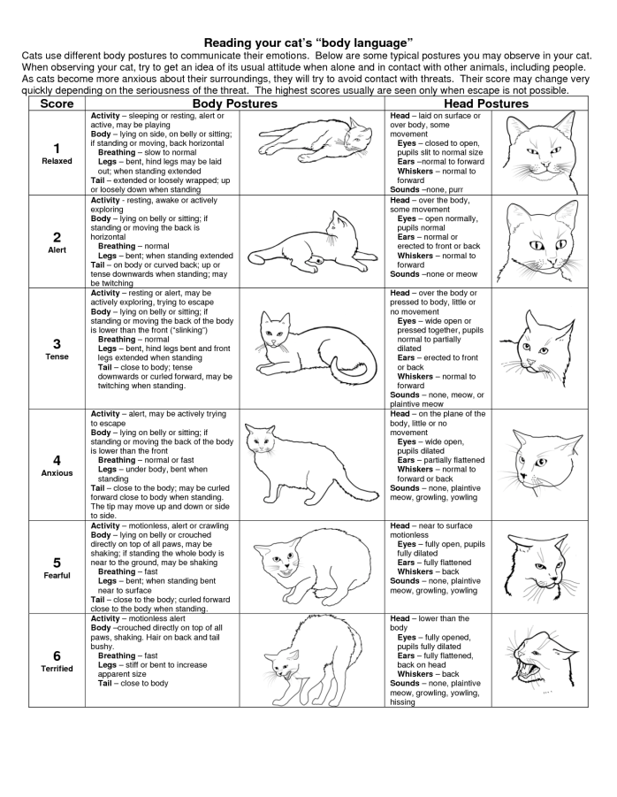](https://www.google.nl/url?sa=i&rct=j&q=&esrc=s&source=images&cd=&cad=rja&uact=8&ved=0ahUKEwix5bLsw5XWAhUIahoKHWnuDW0QjRwIBw&url=https%3A%2F%2Fwww.pinterest.com%2Fpin%2F407857309982503783%2F&psig=AFQjCNFtZmbLNxCLX8oT60E8_iStrKAq9A&ust=1504958068408116)